 |  | TERMO DE ACEITE TÉCNICO
Solicitante: VIVO- Projeto Escolas Rurais
NOC/Operador: Rogério Momi Frias |  |  | Cliente: VIVO
Empresa  EMC Brasil | VSAT-ID  VIVO-PER-27044386-MG |  | Link kbps  256/128 | Plataforma  VSAT
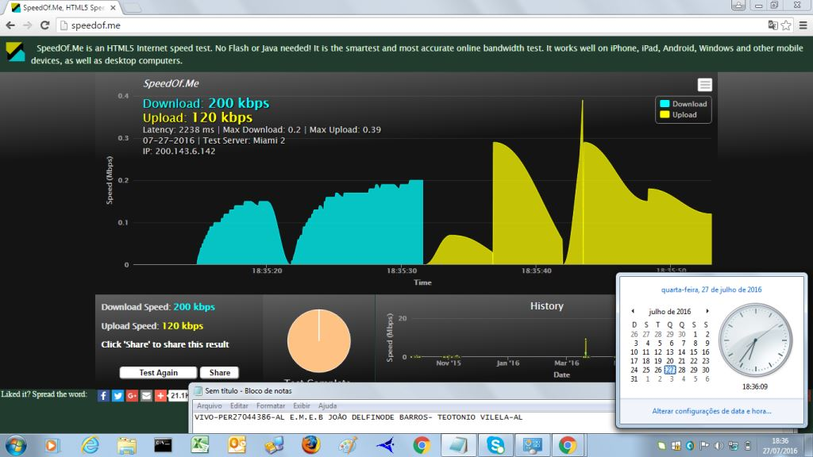

Satellite (DVB) RX Configuration
--------------------------------
Auto start : Enabled
Max Traffic MODCOD : 23 16APSK-9/10
RX watchdog : 15 minute

Idx Pri SymbRate[Msps] Freq[GHz] Mode PopId SatId Pos SatName Name Enable
* 0 0 9.320000 12.055825 DVB-S2 102 0 0.0 E Yes

Satellite (DVB) Receiver Status
--------------------------------
Rx State : On
DVB State : Forward link up
Network : 1326, T14R Beam
Frequency : 12.054744 GHz
Symbol Rate : 9.320159 Msps
S2 ModCod
- receiving : 15 8PSK-5/6
- current max : 16 8PSK-8/9
Pilot : On
Frame length : Short
DVB S2 Mode : ACM
DVB S2 Stream type : MPEG-TS
Roll off : 0.20
SNR : 13.4 dB
Input Power : -31 dBm

Satellite (DVB) TX Configuration
--------------------------------
Auto start : Enabled
IDU Output Power : -22 dBm
IDU Max Output Power: 0.0 dBm
ODU Output Power : 33.7 dBm
EIRP : 47.0 dBW
Default CW Frequency: 14.125750 GHz
ATM mode : VC-Mux
Header Compression : None

Satellite (DVB) Transmitter Status
--------------------------------
State : On (DVB-RCS)
IDU Output Power : -18.9 dBm
ODU Output Power : 33.4 dBm
EIRP : 46.7 dBW
Es/No : 12.5 dB
Header Compression : Disabled
Timing correction : -138 us (262288 us)
Frequency correction: -150 Hz

